Terra Madre Travel Competition
“Earthly Goods: Nourishing our Planet Now and Later”
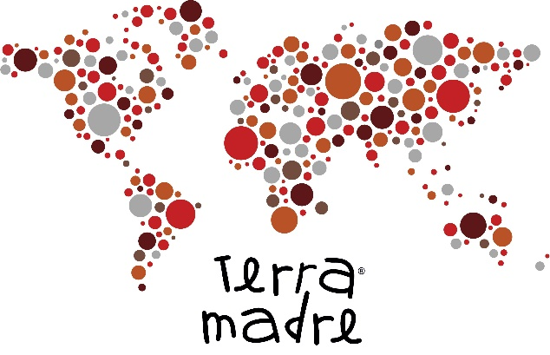
Undergraduate students of Case Western Reserve University are invited to apply for a travel stipend to Slow Food International’s biannual event Terra Madre. The conference will be held September 20-24, 2018 in Turin, Italy. Students (classes of 2019-2021) with strongly demonstrated interests in food movements, nutrition, food culture, and Slow Food are encouraged to apply.
The travel stipend will be awarded to deserving students based on the submission of a related project, short video, and application form. Three or more winners will be chosen to represent Case Western Reserve University’s chapter of Slow Food at Terra Madre and share their experiences once they return.
Application requirements: Applicants will be required to submit a project pertaining to the theme of “food for change”, this year’s Terra Madre theme, emphasizing food as a focus of discussion in climate change and food as a cause, victim, and solution. These guidelines for the project are very flexible to allow for individuals’ creativity, but the projects could take the form of a scientific, artistic, or literary work, for example, a poem, essay, research project, interpretive dance, cooking demonstration, cookbook, etc. A written explanation of the project’s pertinence to the theme will be required as well. In addition, applicants will include a short video (less than 1 minute) introducing themselves and why they want to travel to Terra Madre, from where their interest stems, and why they would be a good fit. These videos will be shared with donors on a Go Fund Me page. Finally, the attached application form will be required.
Important Dates: Submissions will be accepted until midnight of Sunday, April 22, 2018. A panel of judges will review the submissions, and the winners will be announced in late April. It is advantageous to submit projects earlier in the competition in order to garner more funds for the awarded scholarship.
Submissions and questions can be sent to dmk121@case.edu
Videos should be uploaded to YouTube and the link shared in the email submission. Contact Danielle Kulpins at dmk121@case.edu if your project cannot be submitted via email.
Terra Madre Travel Competition
Application form:
Name: ____________________________________ Year of graduation: __________________
Academic Major(s): ______________________________________________________________
Minors: _______________________________________________________________________
Please describe your involvement in food movements, nutrition, food culture, and/or Slow Food:
______________________________________________________________________________________________________________________________________________________________________________________________________________________________________________________________________________________________________________________________________________________________________________________________________
Title of your project: _____________________________________________________________
Please explain how your project fits the theme of Slow Food’s Terra Madre:
__________________________________________________________________________________________________________________________________________________________________________________________________________________________________________________________________________________________________________________________________________________________________________________________________________________________________________________________________________________________________________________________________________________________________

